  - 2026-2027 Jefferson County Grand Jury
April 10, 2027

Garfield’s Deteriorating City Streets

City of Garfield Roads Division
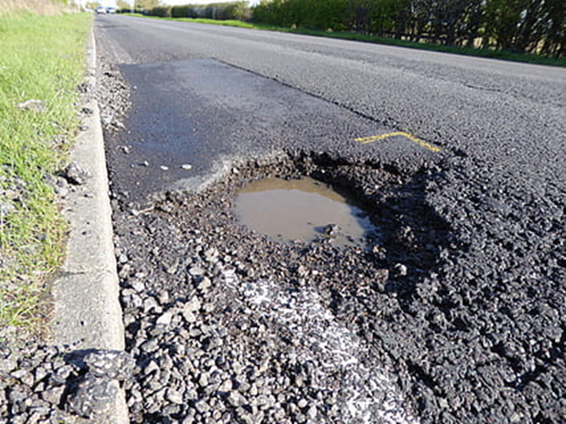

Photo by Jefferson County Grand Jury
Garfield’s Deteriorating City Streets
2026/2027 Jefferson County Grand Jury

SUMMARY
The Jefferson County Grand Jury’s decision to conduct this investigation into local street conditions was prompted by several articles in the Jefferson Recorder and by a complaint submitted to the grand jury by a Garfield resident.
During our investigation, we found that many California county and city road departments are suffering from ongoing funding shortfalls. However, Garfield was the only city in Jefferson County that failed to take advantage of a readily available funding source that could have brought approximately $300,000 into the city’s pavement management program during each of the last two fiscal years. We concluded that this is one reason why Garfield’s streets are in worse condition overall than those in other parts of the county.
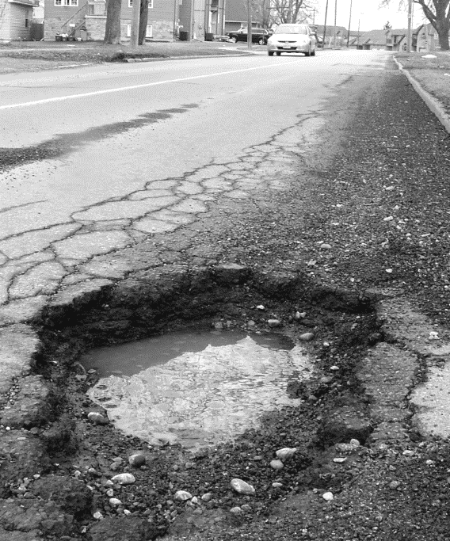
Figure 1: Pothole on Coolidge Street, near Adams Lane, in Garfield, August 26, 2026.
(Photo by Jefferson County Grand Jury)
We also discovered two other problems with the operations of the Roads Division of the Garfield Public Works Department. The Roads Division failed to complete a required paving condition survey (which resulted in its inability to obtain that additional funding), and it lacks a formal procedure for responding to residents’ requests for street repairs or maintenance.
The grand jury also put to rest another concern. We determined that state law prohibits the diversion of state funds earmarked for a new bus for the regional transit system to the city’s road maintenance account.
The grand jury acknowledges that the Roads Division has taken preliminary steps to hire staff to conduct the paving condition survey and to draft a procedure for handling requests for street repairs – but neither project is close to completion.
We recommend that Garfield promptly update its survey and apply to the Jefferson Transit Authority for approximately $300,000 in supplemental funding for the city’s road maintenance program for the upcoming fiscal year. We also recommend that the city adopt a procedure for handling residents’ complaints or requests for road maintenance and repairs.

BACKGROUND
Last summer, the Jefferson Recorder ran a series of articles on the deteriorating roadways in Jefferson County, especially in Garfield. Those articles led to a flurry of letters to the editor, most of which questioned the funding priorities of our county and city officials. Several letters noted the recent purchase of a new bus for the regional transit system and suggested that that money could have been better spent on filling potholes.
Not long after that, the grand jury received a written complaint on this topic from a Garfield resident, who claimed that the street where the complainant lives has not been repaired by the city for ten years, while a street in another Garfield neighborhood, where a city official lives, has been resurfaced twice during that period. The resident questioned whether the official has received preferential treatment.
The complaint also stated that the Garfield Roads Division failed to acknowledge repeated voicemail and email messages requesting road repairs. We looked at the city’s website and could not find information about how to submit requests for road maintenance or repairs.
The grand jury interviewed the complainant and then toured the streets in the complainant’s neighborhood and in nearby neighborhoods. We also looked at several other streets in Garfield, Pierce, and the unincorporated areas of the county that had been described in the Jefferson Recorder articles.
We confirmed that there are clear disparities in the condition of local streets, and we decided to conduct a full investigation, focusing on the operations of the Roads Division of the Garfield Department of Public Works.

METHODOLOGY

Documents
The grand jury reviewed the following documents from the Garfield Public Works Department:
- Garfield Paving Conditions Survey, Management Program, and Plan, 2021
- Garfield Public Works Department Policies and Procedures Manual, Chapter 5, “Street Maintenance and Repair,” May 1, 2023
- Road conditions complaint file, containing documentation of 43 complaints and 17 responses from January 2018 through January 2026
We also reviewed:
- Jefferson Recorder: What’s Happening to Our Roads? June 29, 2026; Garfield’s Rough Roads, July 12, 2026; Holes in the City’s Roads Budget, July 24, 2026
- County of Jefferson Paving Condition Survey and Plan, 2021
- City of Garfield FY 2025/2026 Budget – Public Works Department
- City of Garfield Personnel Rules, Chapter 2, “Conflicts of Interest”
- City of Garfield, index of minutes of City Council meetings, 2021-2026
- City of Pierce, Pavement Survey/Plan, 2024
- Jefferson Transportation Authority: Prop 42 Funding Guidelines and funding application
- California Department of Transportation: Pavement Condition Index for California Counties and Cities, 2024
- California Association of Cities: Local Streets and Roads: A System in Crisis, 2023
- Property tax records of one city official from 2020 to present

Site Visits
The grand jury spent more than ten hours inspecting streets and roads in the cities of Garfield and Pierce and in selected residential areas in the unincorporated areas of the county.

Interviews
During this investigation, the grand jury interviewed 17 individuals, including the complainant and other residents; several administrators, managers and employees of the Garfield Public Works Department; members of the Garfield City Council; administrators of the Jefferson Transportation Authority; managers and staff of the Jefferson County Public Works Department and the Pierce Public Works Department; and Jefferson County Tax Department personnel.

DISCUSSION

The Condition of Garfield’s Roads
Jefferson County has a total of 2,157 miles of roadway, with 98 miles owned by the state, 927 miles located in the unincorporated areas of the county, and a total of 1,132 within the boundaries of the county’s five cities, with Garfield having the largest share at 432 miles.
The condition of local roads throughout California has been in decline for the last two decades and has reached a critical level. According to a 2024 study commissioned by the California Association of Cities, on a scale of zero (failed) to 100 (excellent), the statewide average pavement condition index (PCI) rating is now 62 (good).
However, the statewide PCI rating is expected to decline to 48 (fair) by 2035. According to the study, the acceleration of road deterioration is jeopardizing the state’s economy and is likely to further harm industries such as tourism, manufacturing and construction.
Most California counties and cities regularly inspect and rate their roads as part of a road maintenance plan.
Jefferson County’s most recent survey, completed in 2025, indicated an average PCI rating of 55 (the top end of the “fair” category) for county-maintained roads. The City of Pierce’s 2024 survey showed an overall PCI rating of 49 (fair), whereas Garfield’s most recent survey (from 2021) yielded an overall rating of only 39 (poor).
As we note in the next section of this report, overall, the condition of Garfield’s roads has become progressively worse since 2021.
The following chart, produced by the grand jury based on city data, shows the 2021 PCI ratings for Garfield’s highways (collector and arterial roads) and residential streets. The chart illustrates that six years ago, Garfield rated the condition of 52% of its roads as poor, very poor, or failed.

Table 1: Garfield Pavement Condition Summary: 2021
PCI Range | Condition | Highway Miles | Residential Street Miles | TOTAL | % of Network
86-100 | Excellent | 7 | 0 | 7 | 1.6%
71-85 | Very Good | 19 | 0 | 19 | 4.4%
56-70 | Good | 13 | 24 | 37 | 8.6%
41-55 | Fair | 83 | 62 | 145 | 33.6%
26-40 | Poor | 80 | 112 | 192 | 44.4%
11-25 | Very Poor | 7 | 16 | 23 | 5.3%
0-10 | Failed | 3 | 6 | 9 | 2.1%
 | Total Miles | 212 | 220 | 432 | 100%

Our investigation revealed that poor road conditions are usually caused by inadequate or untimely maintenance rather than poor construction practices. In addition to deferred maintenance, deterioration is caused by traffic volume and loads, weather (especially extreme heat or cold and heavy precipitation), the type and age of the pavement, and the soils and base materials under the roadway.
Typical preventive maintenance tasks include surface treatments such as chip sealing and slurry sealing, which are usually preceded by crack and pothole filling. For more serious or extensive damage, areas of asphalt must be removed. The subsurface must then be repaired or replaced before a new surface is laid.
We learned that timely preventive maintenance is more effective at preserving roads than having to reconstruct roads after they have crumbled. The use of a surface treatment can eliminate the need for expensive pavement patching or overlays and will add years to the life of existing pavement. A slurry seal costs about $0.20 per square foot, compared to $1.80 for a major overlay or $5.50 for reconstruction for the same area. This works out to a cost of about $38,000 for a slurry or chip seal applied to one mile of a residential street on a seven-year cycle. In contrast, reconstruction of poorly maintained roads can cost as much as $1,000,000 per mile.

The Ongoing Funding Shortfall
It is expensive to maintain local roads. However, due to the priority given to other government programs, funding for road maintenance has been declining over the last two decades.
Today, statewide, about 6% of the money for local roads comes from the federal government through a number of programs such as the Regional Surface Transportation Program. About 61% comes from the state, mostly from gas taxes. The remainder, typically about 33%, comes from the local entity’s own funds, such as locally adopted sales taxes, traffic impact fees and developer fees.
In Garfield, a smaller percentage of its roads funding comes from local sources – only 14%. The following chart, based on data supplied by the city, shows Garfield’s road maintenance revenues since fiscal year 2016/17. It illustrates that the funding has declined most sharply during the most recent two years.
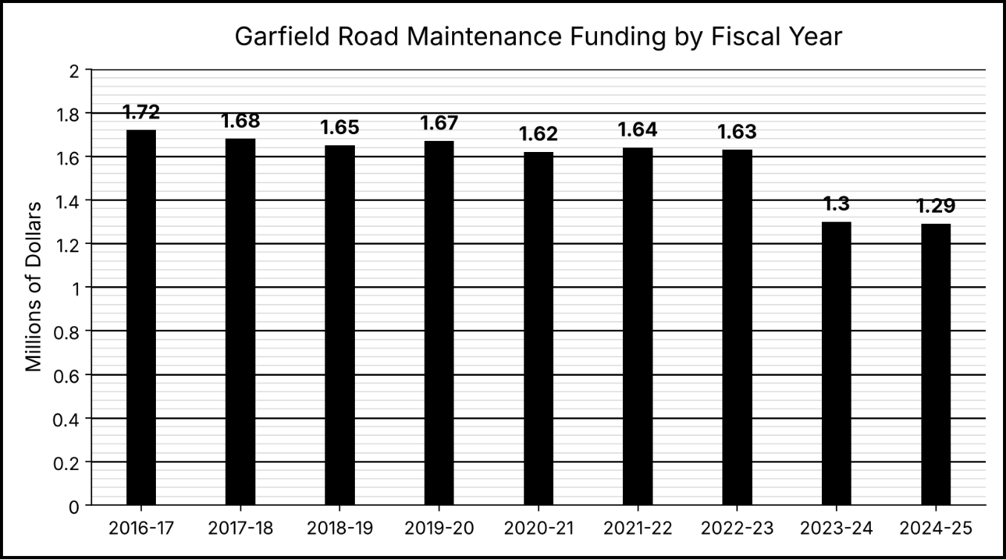
We learned that Garfield should be spending about $3.2 million each year for road maintenance and rehabilitation. The city’s current $1.29 million maintenance and repair budget means that this year the city is deferring about 60% of the work that should be done. This chronic underfunding has led to accelerated deterioration of city roads and will result in significantly higher costs for road rehabilitation in future years.
During our investigation, we found that Garfield has failed to take advantage of a readily available funding source: the Jefferson Transportation Authority, a joint powers agency that distributes locally adopted sales tax proceeds among Jefferson County and its five cities. The distribution is based on a formula using the roads’ PCI ratings. The application due date for the upcoming year is December 15, 2027. To be eligible for funding, an entity must have updated its pavement management plan, including the PCI ratings for all roads, during the prior three years.
Garfield last updated its plan in December 2021 and therefore became ineligible for authority funding beginning with the 2024/2025 fiscal year. Garfield lost approximately $300,000 per year in road maintenance revenue during fiscal years 2024/2025 and 2025/2026. Even if this funding had been obtained, Garfield, like most California cities, would still be underfunded for road maintenance. However, if it had received the Authority’s funding, Garfield could have reduced the percentage of deferred maintenance from 60% to “only” 50% of the maintenance work that is needed and thereby slowed the deterioration of the city’s road system.
We wanted to know why the Roads Division has not yet (as of April 1, 2027) submitted its plan to the Authority. We heard differing explanations, including the layoff of one of the two analysts who worked on earlier surveys, as well as other staffing shortages throughout the Roads Division. We also learned that the Authority changed its eligibility criteria in 2024, requiring new surveys of about a quarter of the city’s roads and revisions of some of the plan language.
These factors may well have contributed to the delay, but the other cities in Jefferson County managed to update their plans. The cost of hiring a consultant to complete the survey and apply for funding is estimated to be $18,000 to $20,000, a small sum compared to the amount it could bring into the road maintenance budget.
After the grand jury initiated this investigation, the public works director submitted to the city manager a request to reinstate the analyst position. This would enable a paving condition survey to be conducted and an application to be submitted to the Authority in 2028. But if the city hired a consultant to do the work now, it could apply for funding by the December 15, 2027 deadline.

Other Garfield Roads Division Issues
The grand jury also examined other matters related to Garfield’s road maintenance program. A resident asked if the city gave preferential treatment to a high-ranking city official by repairing and maintaining the official’s street more frequently than other similar residential streets. We interviewed the official and reviewed the property tax bills for the official’s home and others in the subdivision. We confirmed that the official, and all property owners in the subdivision, pay for road maintenance and repair through an assessment similar to a homeowners’ association. The city does not maintain the streets in that subdivision.
We also determined that Garfield does not have a written policy for handling residents’ complaints about city streets or requests for repairs. There are no means by which complaints and requests can be tracked and no timeline for staff to respond. We interviewed several residents whose requests were never acknowledged and whose streets were never repaired. All of them were critical of the roads division because of its lack of responsiveness. Further, there is nothing on the city’s website to explain to residents how they can communicate with the city about street problems.
After our investigation was underway, the public works department put a temporary procedure in place for handling complaints and began drafting a formal procedure to be submitted to the city council. As of the date of this report, the procedure has not been adopted.
Finally, the grand jury determined that the $297,000 in Proposition 2C Public Transportation Modernization Program funds that the Jefferson Area Rapid Transit System recently received cannot be diverted to help pay for city street repairs. Under state law, the funding must go back to the state if it is not used for the purpose specified in the entity’s funding application, which was the replacement of a 20-year-old bus that is no longer cost-effective to operate.

FINDINGS
F.1 Garfield’s failure to update its paving maintenance plan by the required deadline has resulted in the loss of badly needed road maintenance and repair funding to the city from the Jefferson Transportation Authority.
F.2 Because of the city’s failure to obtain Jefferson Transportation Authority funding, the streets in Garfield are in a worse condition overall than the streets elsewhere in Jefferson County and the deterioration is accelerating.
F.3 Garfield’s lack of a formal procedure for receiving and processing residents’ requests for street maintenance has led to public frustration about the Roads Division’s lack of responsiveness.
F.4 The Garfield Public Works Department has demonstrated its recognition of the above problems by taking steps to hire staff and drafting a procedure for handling complaints and street repair requests. The Grand Jury commends the department for its efforts so far.

RECOMMENDATIONS
The Jefferson County Grand Jury recommends that:
R.1 The Garfield City Council require the director of public works to update the 2021 paving management plan and submit it with an application for funding to the Jefferson Transportation Authority by the December 15, 2027 deadline.
R.2 The Garfield City Council adopt a formal procedure for handling residents’ requests for street repairs by December 1, 2027.
R.3 The Garfield City Council post a summary of the procedure for handling residents’ requests for street repairs on its website, along with directions for reporting road problems, no later than January 1, 2028.

REQUIRED RESPONSES
Pursuant to Penal Code sections 933 and 933.05, the following response is required:
- The Garfield City Council: respond to F1-F3 and R1-R3 within 90 days of the public release of this report.

INVITED ReSPONSES
The Grand Jury invites the following individual to respond:
- The Garfield Director of Public Works: respond to F1-F3 and R1 and R2 within 90 days of the public release of this report.
Responses must be submitted to the presiding judge of the Jefferson County Superior Court in accordance with the provisions of Penal Code section 933.05. Responses must include the information required by section 933.05.

Reports issued by the grand jury do not identify the individuals who have been interviewed during the investigation. Penal Code section 929 requires that reports of the grand jury not contain the name of any person or facts leading to the identity of any person who provides information to the grand jury.

