2023-2024 Jefferson County Grand Jury

The Cleveland Community Services District: Pesticide Management Issues

May 10, 2024

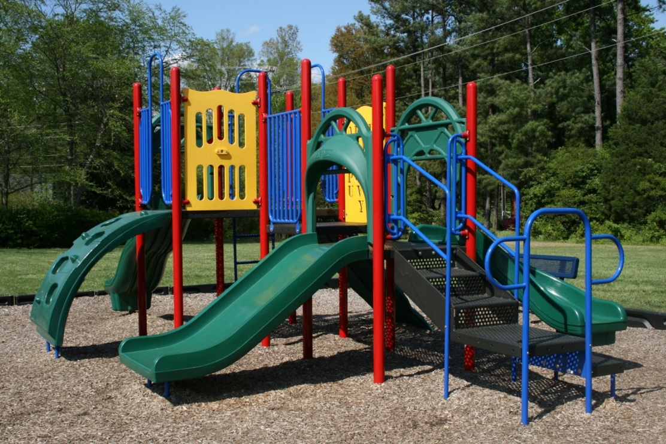

The Cleveland Community Services District:
Pesticide Management Issues

2023-2024 Jefferson County Grand Jury

SUMMARY

The Jefferson County Grand Jury was prompted to conduct this investigation of the Cleveland Community Services District (CCSD) by a complaint from a local resident about the district’s pesticide spraying adjacent to the Cleveland Playground and Freshwater Creek, a district drinking-water source.
During the investigation, the grand jury learned that more than 150 million pounds of pesticides – a term that includes insecticides and herbicides – are being used in California each year. Much of it is applied to public lands by the state and by local governments. Some of these chemicals, including those known as Category II pesticides, can be harmful to humans, pets, and wildlife.

Many local governments, including CCSD, have adopted plans that govern their use of pesticides. The grand jury learned that the district was not complying with its own plan in two respects: the board of directors did not annually approve the spraying method or schedule for Category II pesticides, and CCSD failed to notify nearby residents and playground users of its pesticide spraying. The grand jury also learned that the timing of CCSD’s water quality testing specified in the plan prevented the district from determining if its spraying resulted in the contamination of a drinking-water source. We recommend the district revise its plan – and comply with it.
CCSD tractor applying pesticide on vacant field near playground on May 13, 2023

The grand jury also discovered that CCSD has no procedure for responding to residents’ complaints or requests for information related to district activities. We recommend the district develop and adopt such a procedure.

Soon after beginning the investigation, the grand jury found that CCSD was not in compliance with two of the provisions of the Brown Act, California’s “open meeting” law: a direct link to the board’s meeting agendas was not prominently posted on CCSD’s website’s home page, and the agenda item descriptions were often too vaguely worded to fully inform the public what action the board was considering. A few months into our investigation, CCSD began posting a link to the meeting agenda in a prominent spot on its home page and improved the clarity and completeness of its agenda item descriptions. We commend the district for taking these steps.

BACKGROUND

CCSD, an independent special district, was created in 1968 by a vote of local residents to provide water and sewer services in a residential community west of the Garfield city limits. In 1995 the voters authorized the district to operate a local park, known as the Cleveland Park and Playground, located on district-owned land along the north bank of Freshwater Creek and close to the most populous part of the district. About 18,000 people live in the district.

The grand jury received a written complaint stating that on May 13, 2023, a CCSD employee used a tractor with a commercial-grade spraying device to apply a pesticide to a large vacant field owned by CCSD adjacent to the Cleveland Playground and Freshwater Creek. The complaint stated that the pesticide drifted across the creek and into the complainant’s neighborhood, causing the complainant and others to suffer skin and eye irritation.

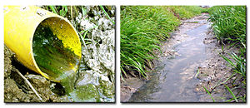
Resident’s May 13, 2023 photo of runoff into Freshwater Creek
The complaint also stated that within minutes after the spraying, a thundershower caused some of the pesticide to run off into the creek, the main source of drinking water for district residents. The complainant’s neighbor had a lab test the water, and it was found to be contaminated. The complainant provided photographs of the spraying and the resulting runoff and a copy of the lab report. Finally, the complaint stated that the district failed to acknowledge repeated voicemail and email messages asking for information about the spraying.

The grand jury interviewed the complainant and then walked through the complainant’s back yard, the playground, and the adjacent field. We also looked at the district’s website and could not find information about how to submit complaints or requests for information.

Because of the possible public health implications of pesticide use, the grand jury decided to conduct a full investigation into CCSD’s pesticide spraying practices.

METHODOLOGY

Documents

During its investigation, the grand jury reviewed numerous documents, including:
- Cleveland Community Services District Municipal Service Review, dated July 1, 2019 (conducted by Jefferson County Local Agency Formation Commission)
- CCSD’s Integrated Pest Management Plan, dated April 1, 2018
- CCSD’s Policies and Procedures
- CCSD’s water quality control inspections logs from 2019 to 2023
- State laws and regulations related to pesticide application
- Several publications of the California Department of Pesticide Regulation and the US Environmental Protection Agency related to Category II pesticides
- Publications about the use of pesticides by local governments

Site Visits

The grand jury conducted a site visit of the complainant’s backyard and the CCSD’s vacant field and playground, both of which are located across Freshwater Creek from the neighborhood where the complainant lives. We also observed two meetings of the CCSD Board of Directors.

Interviews

The grand jury interviewed 17 people, including the complainant and other district residents; several administrators, managers, and employees of CCSD; members of the CCSD Board of Directors; and representatives of the Jefferson County Local Agency Formation Commission and the Jefferson County Agricultural Commissioner’s office.

DISCUSSION

District Compliance with the Notice Requirements of its Integrated Pest Management Plan

The California Department of Pest Regulation recommends that every local public entity owning parks or open lands adopt an Integrated Pest Management Plan (“IPM Plan”) for its use of pesticides to control insects, weeds, rodents, and other organisms that pose health or safety risks to members of the public. Pesticides can harm humans, pets, and wildlife. The department’s publications state that adoption of a written policy and procedures for making pest management decisions can lead to the more efficient, more effective, and safer resolution of pest problems.

CCSD adopted an IPM Plan in 2019. It addresses the types of pesticides (herbicides, insecticides, and rodenticides) the district can use, the timing of pesticide applications, the notifications to be made prior to pesticide applications, and procedures for water quality testing. The plan also requires any CCSD employee who applies pesticides to be certified as a “pesticide applicator” by the Jefferson County Agricultural Commissioner (the local official who enforces state laws and regulations relating to pesticide labeling, storage, and use).

Paragraph 4C of the IPM Plan provides that each spring, district staff must present to CCSD’s board of directors a proposed pesticide spraying schedule for the year. This schedule is to be placed on the board’s “action item agenda” for discussion, possible modification, and adoption. The grand jury learned this has not been done since February 2020.

The grand jury determined that the pesticide sprayed by district staff on May 13, 2023, was a Category II pesticide, which is one that is defined as moderately toxic and moderately irritating. Paragraph 4D of the IPM Plan, which requires the district to give notice to residents and others about Category II pesticide applications, provides in part:

Notification of all Category II pesticide applications shall be posted every 500 feet along the edge of the property where the pesticide is to be applied at least 72 hours in advance of the application.

In any riparian area, applications will be plant-specific and ordinarily limited to wick applications. If a broader application is needed, the board of directors will provide specific authorization for spraying pesticide on a case-by-case basis and shall require CCSD personnel to attempt direct notification to residents occupying homes within 500 feet of the application site, at least 72 hours in advance of the application.

CCSD did not post a notice of the May 13, 2023 pesticide spraying along the edge of the field near Freshwater Creek and the Cleveland Playground. The spraying was in a riparian area and was accomplished using a tractor sprayer, not a hand-held wick, but residents who lived within 500 feet of the field were not given direct notification of the spraying. In fact, the notifications required by CCSD’s plan had not been provided to anyone since February 2020.

The jury also determined that the district’s board of directors did not authorize the tractor application of the pesticide, as required by the IPM Plan.

Acute Toxicity Levels and Effects for Category II Pesticides

Route of Administration | Toxicity Level
Oral | From 50 to 500 mg/kg
Inhalation | From 0.2 to 2 mg/L
Dermal contact | From 200 to 2000 mg/kg
Effects
Dermal effects | Severe irritation at 72 hours
Ocular effects | Corneal opacity, reversible within 7 days; irritation persisting for 7 days

As shown in this chart, Category II pesticides can cause skin and eye irritation that can last for several days after exposure.

The grand jury interviewed a number of residents in the complainant’s neighborhood. Four of them had become aware of the spraying due to its acrid smell. Two suffered skin and eye irritation after smelling the pesticide. They may have been able to avoid exposure to the pesticide had they been notified of the spraying schedule.

The District’s Water Quality Testing Program

CCSD provides drinking water to over 4,300 households. The district’s primary water source is the Freshwater Basin/, which is located on the west side of the district. The basin and aquifer are fed, in part, by Freshwater Creek.

The grand jury confirmed through the National Weather Service that a thunderstorm hit the area, including the basin and Freshwater Creek on the afternoon of May 13, 2023, dropping over an inch of rain in less than an hour, enough rain to cause significant amounts of pesticide runoff.

According to the California Department of Pesticide Regulation and the United States Environmental Protection Agency, most Category II pesticides dissipate in water within 10 days. However, Section 6 of CCSD’s IPM Plan requires district staff to arrange for testing water from the basin each fall, about six months after the spring spraying has been completed.

District Responses to Residents’ Complaints or Requests for Information

The Jefferson County Local Agency Formation Commission (LAFCO) prepared a Municipal Service Review of CCSD’s finances and services in 2016. In that document, LAFCO recommended the district adopt a written policy for handling residents’ complaints about district services and activities.

CCSD does not have a written policy for responding to residents’ requests for information or complaints. There are currently no means by which requests and complaints can be tracked and no timelines for staff to respond. The grand jury interviewed five residents whose requests or complaints were never acknowledged. All of them were frustrated by and critical of the district because of this. However, we learned the district’s managers are now developing such a policy.

CCSD Board of Directors’ Meeting Agendas

Effective January 1, 2019, the Ralph M. Brown Act, California’s “open meeting” law, was amended to require that any local agency with a website include on its home page a prominent, direct link to its governing board’s meeting agendas. (Government Code §54954.2)

The grand jury reviewed CCSD’s website archives and determined that during 2022 and 2023, the district’s website home page did not display a prominent, direct link to the agendas for the CCSD’s Board of Directors’ meetings. Instead, someone looking for agendas had to look under “District Information” to find them.

In addition, California case law requires that each description of any matter on the agenda that will be discussed or voted upon by the governing board be worded in a way that accurately explains to the public what the contemplated discussion or action will include. Ten of the twenty-four agendas from January 2022 to December 2023 included descriptions for “action items” (matters that were to be voted on by the board) that failed to clearly identify the nature of the action that was to be voted on. Twelve items referred to contracts but did not include the cost.

In January 2024, a few months after the grand jury’s investigation began, CCSD modified its website’s home page to include a prominent, direct link to its board’s agendas. In addition, the agenda item descriptions became more descriptive, clearly identifying the nature of the recommended action and the projected cost. The grand jury commends CCSD for making these changes.

FINDINGS

F1. The Cleveland Community Services District (CCSD) Board of Directors failed to annually approve its spraying schedule for Category II pesticides for the past three years as required by its Integrated Pest Management Plan.

F2. CCSD’s failure to provide notification of Category II pesticide spraying led to residents and playground users being caught unaware of the spraying and caused some of them to suffer avoidable side effects.

F3. CCSD’s water quality testing of Freshwater Creek and the Freshwater Basin/Aquifer each fall is ineffective because it is conducted too late after Category II pesticide spraying adjacent to Freshwater Creek to detect possible contamination of the district’s residential water supply.

F4. CCSD’s lack of a formal procedure for dealing with complaints and requests for information has led to public frustration.

F5. CCSD’s failure to prominently display a link on its website home page to the board of directors’ meeting agendas during 2022 and 2023 as required by the Ralph M. Brown Act made it difficult for residents to locate agendas. However, the website was brought into compliance with that requirement of the Act as of January 2024.

F6. Since December 2023, the items on the agendas for the meetings of the CCSD’s board of directors are adequately descriptive, which has resulted in improved government transparency.

RECOMMENDATIONS

The Jefferson County Grand Jury recommends that:

R1. The Cleveland Community Services District (CCSD) Board of Directors (board) direct staff to present the 2025 Category II pesticide spraying schedule and any recommendation for tractor spraying to the board for adoption at a regular meeting of the board held no later than March 1, 2025, and each March thereafter.

R2. By October 1, 2024, the board require staff to provide advance notice of the district’s spraying of Category II pesticides as required by Paragraph 4D of the district’s Integrated Pest Management Plan, beginning no later than November 1, 2024.

R3. By November 1, 2024, the board require district staff to conduct water quality testing within seven calendar days after any Category II pesticide spraying within 100 feet of any water source that contributes to the district’s residential water supply, such testing to begin with all spraying conducted after November 1, 2024.

R4. By November 1, 2024, the board adopt a formal policy for dealing with complaints and requests for information.

REQUIRED RESPONSES

Pursuant to Penal Code section 933.05, the following response is required:

- The Cleveland Community Services District Board of Directors shall respond to Findings F1-F6 and Recommendations R1-R4 within 90 days of the date of this report.

INVITED RESPONSES

- The Cleveland Community Services District General Manager is invited to respond to Findings F1-F6 and Recommendations R1-R4 within 60 days of the date of this report.

Responses are to be submitted to the Presiding Judge of the Jefferson County Superior Court and must contain the information required by Penal Code section 933.05.

Reports issued by the grand jury do not identify the individuals who have been interviewed during the investigation. Penal Code section 929 requires that reports of the grand jury not contain the name of any person or facts leading to the identity of any person who provides information to the grand jury.

Note: This document is intended to illustrate the structure and wording of a typical grand jury report. The information in this document is fictitious and should not be relied upon for any purpose.

