Social Media Strategy
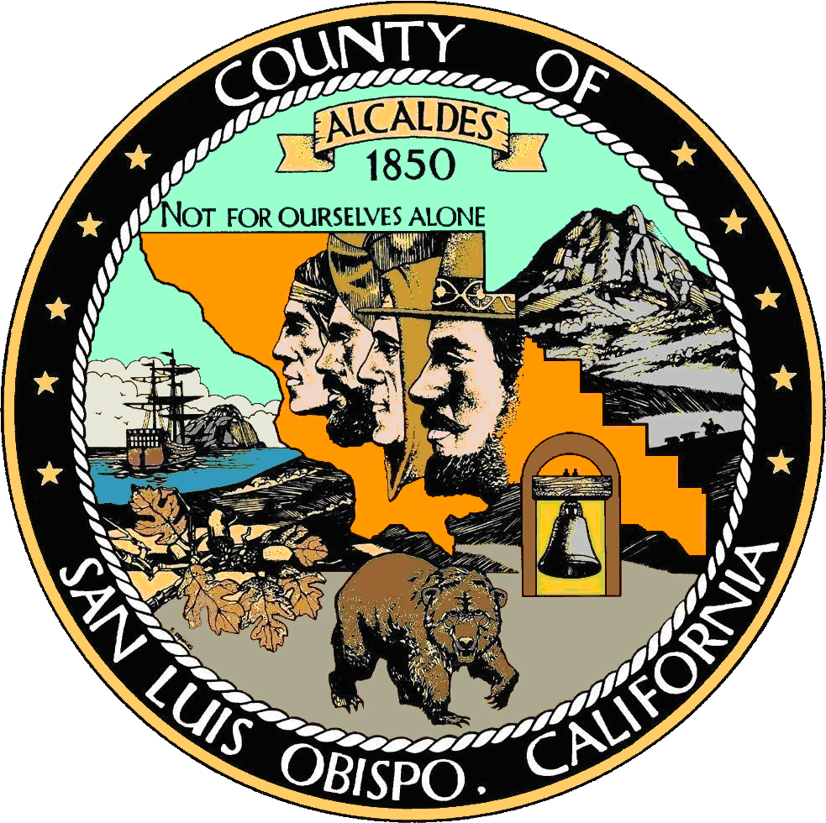

Department Information
DEPARTMENT NAME  San Luis Obisipo County Grand Jury  Facebook: na  Twitter: twitter.com/ SLOGrandJury  YouTube: na | Social Media Manager: Regina Rini, ext. 5188  Current Grand Jury Foreperson: Larry Herbst, ext. 5188  Launch date: March 18, 2015

Summary
The San Luis Obispo County Grand Jury (Grand Jury) uses Twitter as an extension of its news release strategy. It primarily seeks to have individuals in local media, special district, city and county government follows its Twitter account to receive updates regarding publication of Grand Jury reports and other news related to the Grand Jury. It also provide all citizens with an additional access point to its published reports.

Goals
The Grand Jury uses social media, specifically Twitter, to:

- Increase the visibility and coverage of its published reports.
- Increase citizen interest in reading the results of the Grand Jury and participating with the Grand Jury process.
- Increase awareness of the role of the Grand Jury.

Objectives/Measurement
The Grand Jury will evaluate the effectiveness of its use of Twitter by tracking:

- Increase the number of followers to include at least one representative from each of its primary media outlets.
- Reach a total number of followers of 200 within the first year of operation.
- Issue an average of one tweet a week over the fiscal year, with the majority of tweets occurring in the April through June timeframe (when the majority of reports are issued).
- Target the retweeting of those tweets dealing with the release of new reports

Tactics
Because the Grand Jury’s composition changes each year, the focal point for the administration of the actual account will remain the administrative aide to the Grand Jury. However, each year, the Grand Jury Foreperson will seek one member to serve as the overall social media manager for that year’s Grand Jury. The function of that person will be to:
- Promote the visibility of the Grand Jury. Occasional tweets will provide insight into the history and role of the Grand Jury in California to encourage better understanding of this process. In particular, during the months of February through April, a series of tweets will seek to promote the application process for volunteering to serve on the Grand Jury.
- Publicize the issued reports of the Grand Jury. When new reports are released, the Grand Jury will tweet about the report, and include a link to the full report. It will typically do multiple tweets highlighting different aspects of the report during the initial week of the report’s release. In particular, these tweets will be targeted to attract the attention of media contacts and involved citizens, with a goal of having such tweets retweeted or favorited. This work will occur primarily between April and July, when new reports are issued
- Promote previous Grand Jury work. Highlights of previously issued reports will be recapped in the weeks following their initial release to extend the life and visibility of such reports. This work will occur primarily during the months of July through September.
- Highlight the Grand Jury Complaint process. Occasionally, tweets will focus on how citizens are able to submit complaints to the Grand Jury. Such tweets might be reinforced on a monthly basis.
- Promote for great visibility. On tweets dealing with high visibility reports, the Grand Jury might choose to fund the promotion of that Tweet through Twitter advertising or other tools.

Content Strategy
As an organization of volunteers who must work in a collegial and confidential manner, the Grand Jury will see to maintain a highly professional voice in all of its tweets. Its function will primarily serve to expand the visibility of the reports it issues.

Time Period | Theme | Examples of Content to Share
July thru September | Focus on previous reports and role (at least weekly) | - Notes about earlier reports  - Interesting facts about the Grand Jury Process  - Photo of previous Grand Jury  - Highlighting relevant organizations
October thru January | Quieter period (at least every other week) | - Grand Jury history  - Info about other counties  - Complaint process
February thru April | Volunteer period (at least weekly) | - Application process  - Previous grand juror thoughts
April thru June | New reports (multiple tweets per week) | - Highlight new reports

Posting Frequency
List out how often you’ll post to each designated social network. For example:
Tools | Pros/Cons | Posting Frequency/Timing
Facebook | NA | NA
Twitter | Preferred approach for many media followers, but unfamiliar tool to most Grand Jurors | Averaging 1 to 5 per week, depending on time of year
LinkedIn | NA | NA
YouTube | NA | NA

